Before we can talk about composition of functions, we have to make sure we can also carry out the usual algebraic operations on functions, such as addition, subtraction, multiplication, and division.

# Combining Functions Using Algebraic Operations

For two functions $f(x)$ and $g(x)$ with real number outputs, we define new functions $f+g$, $f-g$, $fg$, and $\frac{f}{g}$ by the relations

$$\left(f+g\right)\left(x\right)=$$

$$\left(f-g\right)\left(x\right)=$$

$$\left(fg\right)\left(x\right)=$$

$$\left(\frac{f}{g}\right)\left(x\right)=$$

where $g(x)≠0$. The domain of each of these combinations is the intersection of the domain of $f$ and the domain of $g$. In other words, both functions must be defined at a point for the combination to be defined. However, for the division of functions, the denominator can't be zero.

Examples: Given

$$f\left(x\right)=\sqrt{2x-1}$$

$$g\left(x\right)=x+5$$

$$h\left(x\right)=x^{2}-3$$

$$c\left(x\right)=\sqrt{x+3}$$

Find the following combinations and then determine the domain for each combination.

$\left(f+g\right)(x)$

$\left(gh\right)(x)$

$\left(c-f\right)(x)$

$\left(\frac{h}{g}\right)(x)$

Performing algebraic operations on functions combines them into a new function, but we can also create functions by composing functions.

# Composition of Functions

The process of combining functions so that the output of one function becomes the input of another is known as a **composition of functions**. The resulting function is known as a composite function. We represent this combination by the following notation:

$\left(f o g\right)\left(x\right)=$

The **domain** **of the composite function $f o g$** is all $x$ such that $x$ is in the domain of $g$ and $g(x)$

It is also important to understand the order of operations in evaluating a composite function. We follow the usual convention with parentheses by starting with the innermost parentheses first, and then working to the outside.

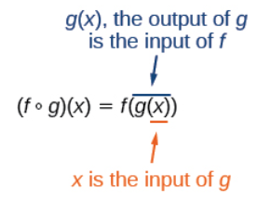

In general, $f o g$ and $g o f$ are different functions. In other words, in many cases $f(g\left(x\right))≠g(f\left(x\right))$ for all $x$.

Examples:

1. Using the functions provided, find $f(g\left(x\right))$ and $g(f\left(x\right))$. Determine whether the composition of the functions is commutative.

$f\left(x\right)=2x+1$ and $g\left(x\right)=3-x$

1. The function $c(s)$ gives the number of calories burned completing $s$ sit-ups, and $s(t)$ gives the number of sit-ups a person can complete in $t$ minutes. Interpret $c(s\left(3\right))$.

# Evaluating Composition of Functions

To evaluate a composition, we begin by evaluating the inner function using the starting input and then use the inner function’s output as the input for the outer function (i.e. work from the inside to the outside).

You should be able to evaluate composite functions regardless of the representation.

Examples

1. Using the graphs below, evaluate $f(g\left(1\right))$.

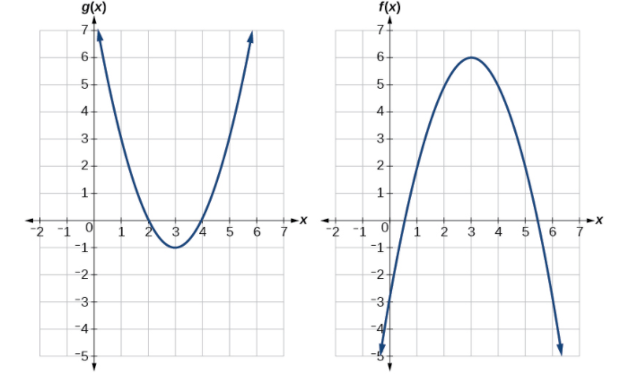

1. Using the table below, evaluate $g(f\left(3\right))$.

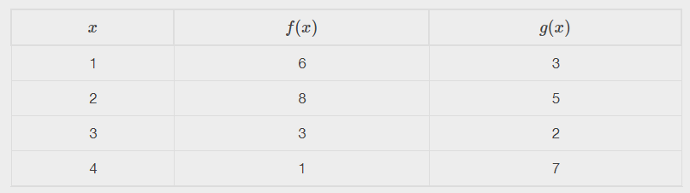

1. Given $f\left(t\right)=t^{2}-t$ and $h\left(x\right)=3x+2$, evaluate $f(h\left(1\right))$.

# Finding the Domain of a Composite Function

The domain of a composite function $f(g\left(x\right))$ is the set of those inputs $x$ in the domain of $g$ for which $g(x)$ is in the domain of $f$.

Given a function composition $f(g\left(x\right))$, we determine domain by

1) Find the domain of .

2) Find the domain of .

3) Find those inputs $x$ in the domain of $g$ for which $g(x)$ is in the domain of $f$. That is, exclude those inputs $x$ from the domain of $g$ for which $g(x)$ is not in the domain of $f$. The resulting set is the domain of $f o g$.

Examples

1. Find the domain of each of $(f o g)(x)$ where $f\left(x\right)=\frac{5}{x-1}$ and $g\left(x\right)=\frac{4}{3x-2}$.
2. Find the domain of each of $(f o g)(x)$ where $f\left(x\right)=\frac{1}{x-2}$ and $g\left(x\right)=\sqrt{x+4}$.

# Decomposing a Composite Function into its Component Functions

Decomposition of functions is the reverse of composition of functions. Instead of combining two functions to get a new function, you're breaking apart a combined function into its separate components. Basically, you want to look at the function and look for an “outside function” and an “inside function.”

Examples

1. If $\left(f o g\right) \left(x\right)=\left|x^{3}-1\right|$,

$f\left(x\right)=$

$$g\left(x\right)=$$

1. If $\left(f o g\right) \left(x\right)={\left(2x-3\right)}^{3}$,

$f\left(x\right)=$

$$g\left(x\right)=$$

1. If $\left(f o g\right) \left(x\right)=\sqrt{x^{4}-17}$,

$f\left(x\right)=$

$$g\left(x\right)=$$